**Interpretive Canoe Trail –** Complete trail (points 1-7) round trip 3.4 miles

Points 1-5 = 1.4 miles RT

Points 1-7 = 3.4 miles RT

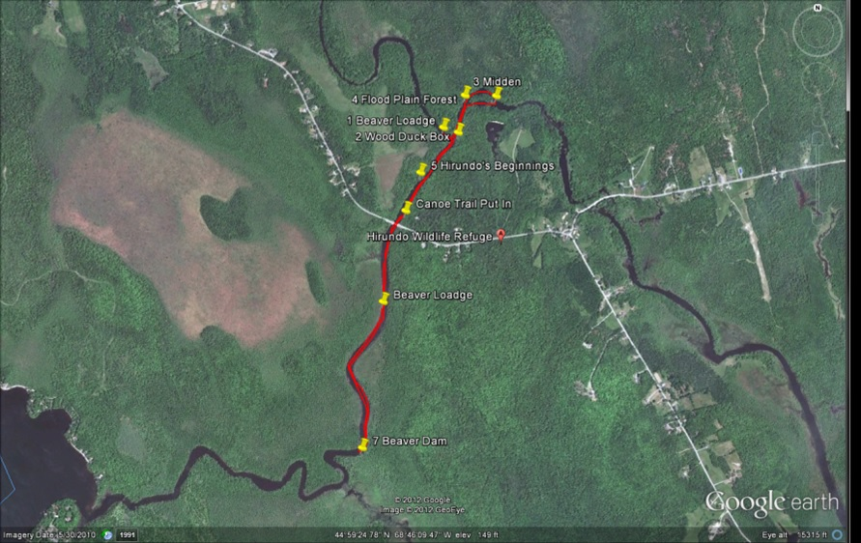

**Canoe Trail to Pushaw Dam** – 5 miles round trip, flat water with numerous beaver lodges, duck boxes, a newly built beaver dam, turtle resting sites.

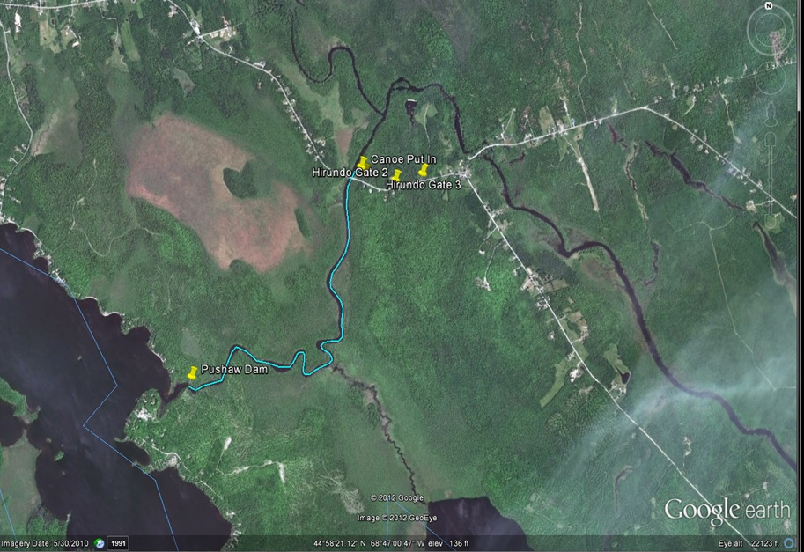

Birds to hear and see: Great Blue Heron, American Bittern, Eastern Kingbird, Northern Harrier, Bald Eagle, Osprey, Red-winged Blackbird, Crackles, Swallows, Mammals: Beaver, Mink, Muskrat, Deer.

Canoe Trip from Tannery Road to Hirundo Gate 3 – 3.4 miles one way.

